**招商銀行香港分行遷址通知**

尊敬的客戶:

為使客戶享有一個更為舒適的銀行服務及環境，本行將於 **2019年4月23日** 起，遷往中環康樂廣場八號交易廣場三期28樓繼續為客戶提供優質服務。

如有疑問，歡迎向本行職員或致電客戶服務熱線 852 - 31195555(香港) 或86755 - 95555(中國內地) 查詢。不便之處，敬請原諒。

**新營業地點**

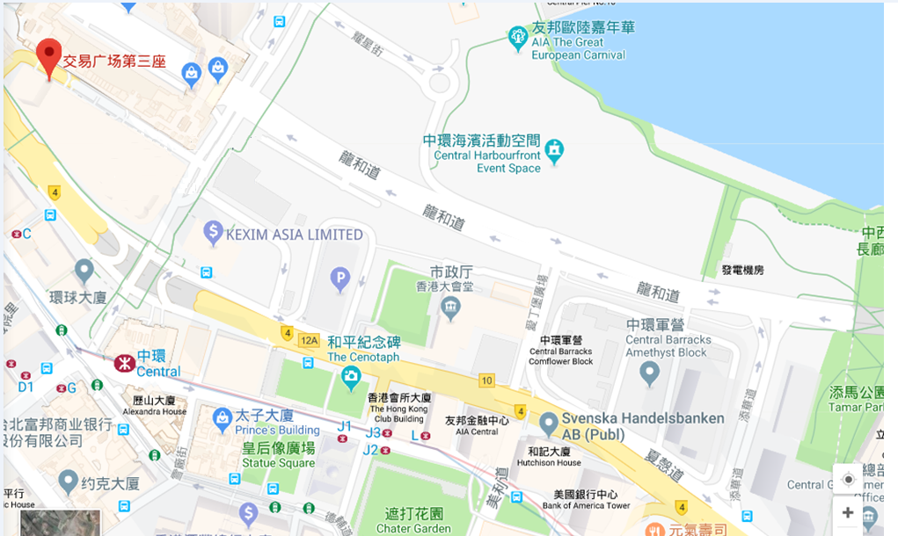

招商銀行香港分行 謹啟

2019年２月21日

**China Merchants Bank Hong Kong Branch**

**Relocation Notice**

Dear Valued Customer  
  
In order to enhance customer experience on our banking services and environment, the Bank will be relocated to the 28th floor of the Three Exchange Square, 8 Connaught Place, Central from **23rdApril 2019** to continue providing high quality of services to customers.   
  
Should you have any questions, please feel free to contact our staff or call our Customer Service Hotline at 852-31195555(Hong Kong) or 86755-95555(Mainland China). We apologize for any inconvenience caused.

New address



**3 Exchange**

**Square**

China Merchants Bank

Hong Kong Branch

21 February 2019